Денис Дубинин, 1 -когорта - 1 спринт

**Часть 1**

1. Mindmap:

https://miro.com/app/board/o9J_lhPZVtk=/

https://docs.google.com/spreadsheets/d/1TkHDVGvvUPqJ6bLOVjI0pv63YH-C3MF7yFH9JvmWpFg/edit?usp=sharing

**Часть 2**

1. Блок-схема:

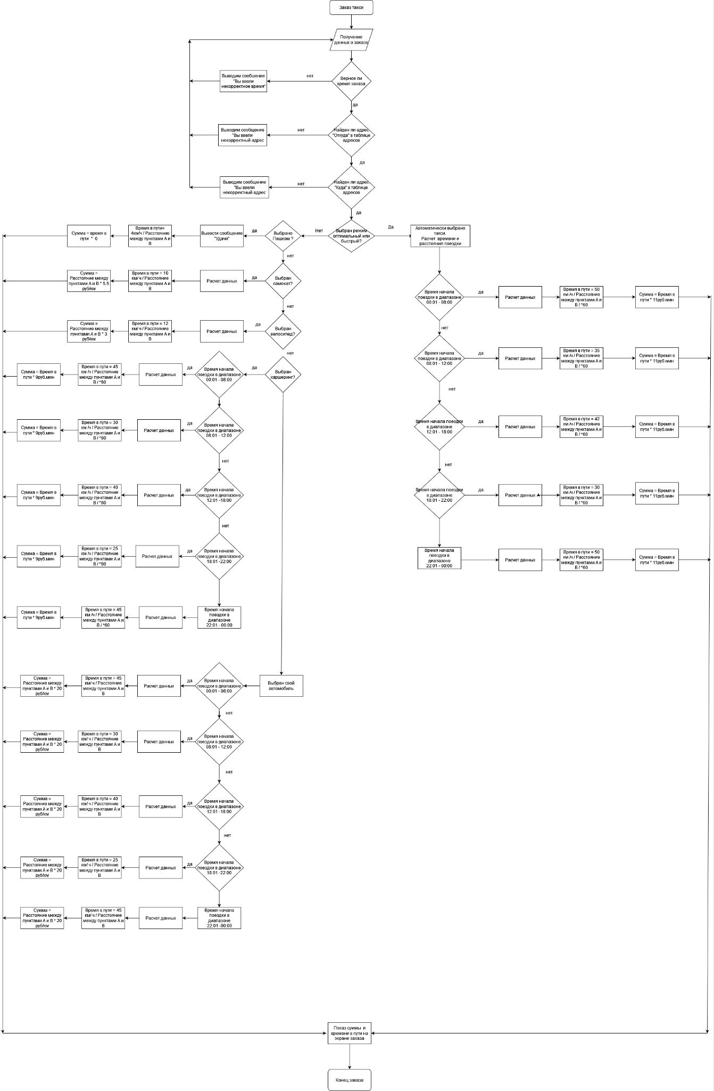

https://docs.google.com/spreadsheets/d/1TkHDVGvvUPqJ6bLOVjI0pv63YH-C3MF7yFH9JvmWpFg/edit?usp=sharing